Doom Eternal is a first-person shooter game developed by id Software and published by Bethesda Softworks. It is the sequel to 2016's Doom and the fifth mainline installment in the Doom series.

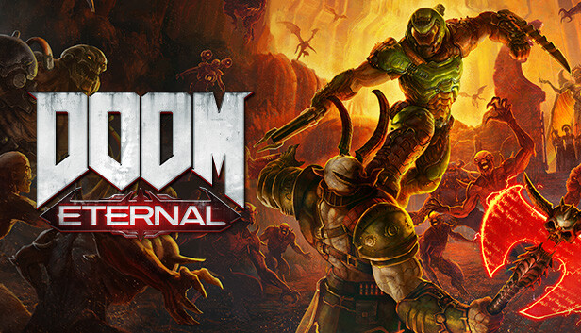

The game was released on March 20, 2020, for PlayStation 4, Xbox One, and Microsoft Windows. It was later ported to Nintendo Switch on December 8, 2020, and PlayStation 5 and Xbox Series X/S on March 15, 2021.

Doom Eternal received generally positive reviews from critics, who praised its fast-paced action gameplay, level design, and soundtrack. The game was a commercial success, selling over 3 million copies by May 2020. It received five nominations at The Game Awards 2020, including Game of the Year and Best Action Game.